**Leek, Lemon, and Feta Quiche**

By [Feeding the Saints (A. C. Parker)](http://food52.com/users/5215-feeding-the-saints-a-c-parker) • [47 Comments](http://food52.com/recipes/2829-leek-lemon-and-feta-quiche#comments)

[◅▻](http://food52.com/recipes/2829-leek-lemon-and-feta-quiche)

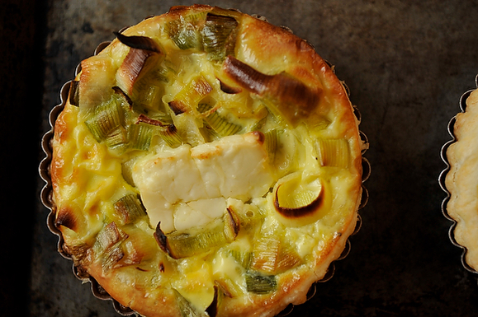

1 of 4*Photo by Sarah Shatz*

[+**SAVE 974**](http://food52.com/recipes/2829-leek-lemon-and-feta-quiche)

[✉](http://food52.com/recipes/2829-leek-lemon-and-feta-quiche/email) [⎙](http://food52.com/recipes/print/2829)

**A&M say:** Feeding the Saints aptly describes these individual little quiches as "light and cheerful." We love the delicate flavor of leeks, and crisp, airy puff pastry is a nic ([**…more**](http://food52.com/recipes/2829-leek-lemon-and-feta-quiche#show more content))

[**Feeding the Saints (A. C. Parker)**](http://food52.com/users/5215-feeding-the-saints-a-c-parker)**says:** While a leek quiche seems indisputably French, this recipe brings a Hellenic “Opa!” to your table with the addition of lemon, feta, and ([**…more**](http://food52.com/recipes/2829-leek-lemon-and-feta-quiche#show more content))

***Serves 1 large quiche or 4 individual-size quiches***

* **1**sheet frozen puff pastry
* **1**pound leeks
* **2**tablespoons extra-virgin olive oil
* **1**cup half-and-half
* **3**eggs
* **1**teaspoon freshly grated lemon zest
* **1**teaspoon kosher salt
* freshly ground black pepper
* **2**teaspoons ouzo (optional)
* **2-1/2**ounces feta cheese, cut into 4 (approx 1/2-inch) slices

1. Preheat oven to 375F. Thaw puff pastry according to package directions.
2. Prepare the leeks. Rise off any visible dirt and slice the roots from the end. Remove the dark green tops, leaving a couple inches of light green with the white portion of the leeks. (The dark trimmings can be reserved for another use, adding them to a vegetable or chicken stock, for example.) Halve the leeks lengthwise, then cut crosswise in 1/2-inch slices. Dump the slices in a colander or salad spinner and rinse thoroughly; if you don’t, you risk having a gritty, sandy quiche, as leeks often hide dirt deep in their layers. Let the leeks drain well, or spin dry.
3. Heat the olive oil in a large skillet over medium heat until it shimmers. Add the leeks and cook until they are wilted; don’t cook them so much that they give off liquid. Turn off the heat and let sit.
4. In a mixing bowl or large measuring cup, using a whisk or fork, beat together the half-and-half, eggs, lemon zest, salt and pepper. Add the ouzo, if using.
5. Prepare the pastry crusts. On a lightly floured surface, or between two layers of plastic wrap or parchment paper, roll out the thawed puff pastry to a thickness of about 1/4 inch. Line a shallow pie plate or cut the pastry into four circles to fill individual baking dishes. Press the pastry up the sides to make a nice edge.
6. Fill the quiches. Distribute the leeks evenly across the bottom of the dish(es). Pour the milk mixture over the leeks. Top the quiche(s) with the slices of feta. (If you have feta that crumbles apart, don’t worry, just sprinkle it on top.)
7. Bake 30-40 minutes, depending on size of the quiche(s). The center should be solid and the crust and top nicely browned. Let the quiche cool for at least 10 minutes before serving. The quiches taste great hot, room temperature, even cold.
8. Enjoy with a simple green salad and a glass of chilled assyrtiko from award-winning Domaine